# INFO 153 – Final Project

Name of Team:

SLWCbest

Team Members (Lastname, Firstname):

1. Shi Bowen
2. Liu Yunong
3. Wang Qi
4. Chao Zichen

Problem Chosen (Major or Activity):

Activity

Name of Product:

actHunter

URL of Product:

<http://immense-depths-9247.herokuapp.com/>

Github URL of Code:

<https://github.com/berwen/FinalProjectFori153>

Product Discovery and Development:

Create a list of all steps your team went through to complete the final project (e.g. definition of problem, initial user interview, brainstorming of potential solutions, etc.)

Additionally, list the responsibilities each of the team members had for each step. Please indicate whether a specific member or the team as a whole has completed that step

1. Choose the problem and answer 4 question -----team as a whole

2. Develop persona -----team as a whole

3. Brainstorm solution -----team as a whole

4. Design and draw story board -----Wang qi and Shi Bowen

5. Develop Prototype -----Liu Yunong

6. Get feedback with prototype -----each person asked for 2 people

7. Improve our UI according to users feedback ----- team as a whole

8. Define MVP ----- team as a hole

9. Develop product -----UI skeleton Liu Yunong

-----visually design Wang Qi ,Liu Yunong, Shi Bowen

----- local storage Chao Zicheng

-----api Shi Bowen

10.Launch the MVP ----- team as a whole

11.Get user feedback and improve the product -----team as a whole

12.Write the team sheet and develop Hypothesis and Metrics -----Shi Bowen

## Business Idea

Please provide a description of the problem you are trying to solve (be specific), what target users you are addressing (use your persona) and for what reason this is a problem worth solving. Try to limit your response to 200 words or less:

**Problem we try to solve is**

1) Some students feel bored, but do not know the day's activity arrangements, and do not know what activities they can participate

2) Many activities released through various channels, causing students to miss some interesting activities.

3) Event organizers in the campaign, it tends to be a lot of poster printing, but also posted everywhere, which cost a lot manpower and resources. Through this platform, the organizers can quickly and simply publish event information, and to collect information on applicants.

Persona

(1)**Name:** Petter

**Gender:** male

**Location (City, Country):**Berkeley

**Profession (education, current position):**EE

**Computer Skills:** skilled user of internet

**What is this person's problem (story):**

Petter is always stay at home because he is busy with his course and don’t know where to find interesting events, but he really want to participant in some event to make more friends.

**Why is this problem for the person?**

He don’t have time to hung around campus to find posters

**What goal does the person have?**

Find the interesting event with least time

**What would the person value most / what would make the person really excited?**

A website that can help him to find interesting event in shortest time

(2) **Name:** Betty

**Gender:** female

**Location (City, Country):** Berkeley

**Profession (education, current position):** economy

**Computer Skills:** skilled user of internet

**What is this person's problem (story):**

Betty want to hold a debate competition, she want more people know it. But there is not enough people to help her to advertise this competition.

**Why is this problem for the person?**

She doesn’t have enough people to advertise this event.

**What goal does the person have?**

Advertise her event with least people

**What would the person value most / what would make the person really excited?**

She just need to type information in our website and people will know this event

**Why the problem is worth solving?**

Because it can enrich students' school life and improve resource utilization, and save paper for posters. And the most important thing, us this website will save you a lot of time!Ideation Process

Please describe in detail a) what process you went through in order to find a suitable solution for the problem above, b) what options you traded off (did you consider multiple solutions?) and c) what response you received from users.

Do not talk about the solution itself; focus on the process and user feedback. Feel free to add quotes or insights from users. Try to limit your response to 300 words or less:

First , we think that how to get the event information? We come up three solution:

1. at the beginning, we can recruit volunteers to collect the events information
2. Collaborate with university club and student organization
3. We host some activities to advertise our website

Second, if an organizer want to host a activity, which information must they provide?

After discussion, our answer is when dose it start and finish, location, event name, description, cost, contact information.

How to organize information: by tag.

After we developed a prototype. We use it to get some feedback. They all like our idea and think that this website is useful. Then we introduce how to use our website, and ask them to give some suggestions. The suggestions are as follows:

1. We don’t have submit button on host an activity page.
2. We should join register function to prevent people from repeated register.
3. We can ask for feedback of participants after they participated in an event and ranking
4. We can base on the feedback and time to rank events
5. We should better to remind organizer to attach their contact information
6. We should add share to button in event detail page

## Solution

Outline in-depth what solution you came us with. Please provide a) an overview what your solution does using the storyboard, b) how a user would use your solution, c) what design tradeoffs you made, and d) what user input you received

Please describe a) and b) only briefly, and c) and d) in detail. Try to limit your response to 200 words or less:

There are so much activities, and Petter just don’t know join which activity. So how should he do? Just go our website and search by tag and find the activities he is interested in.

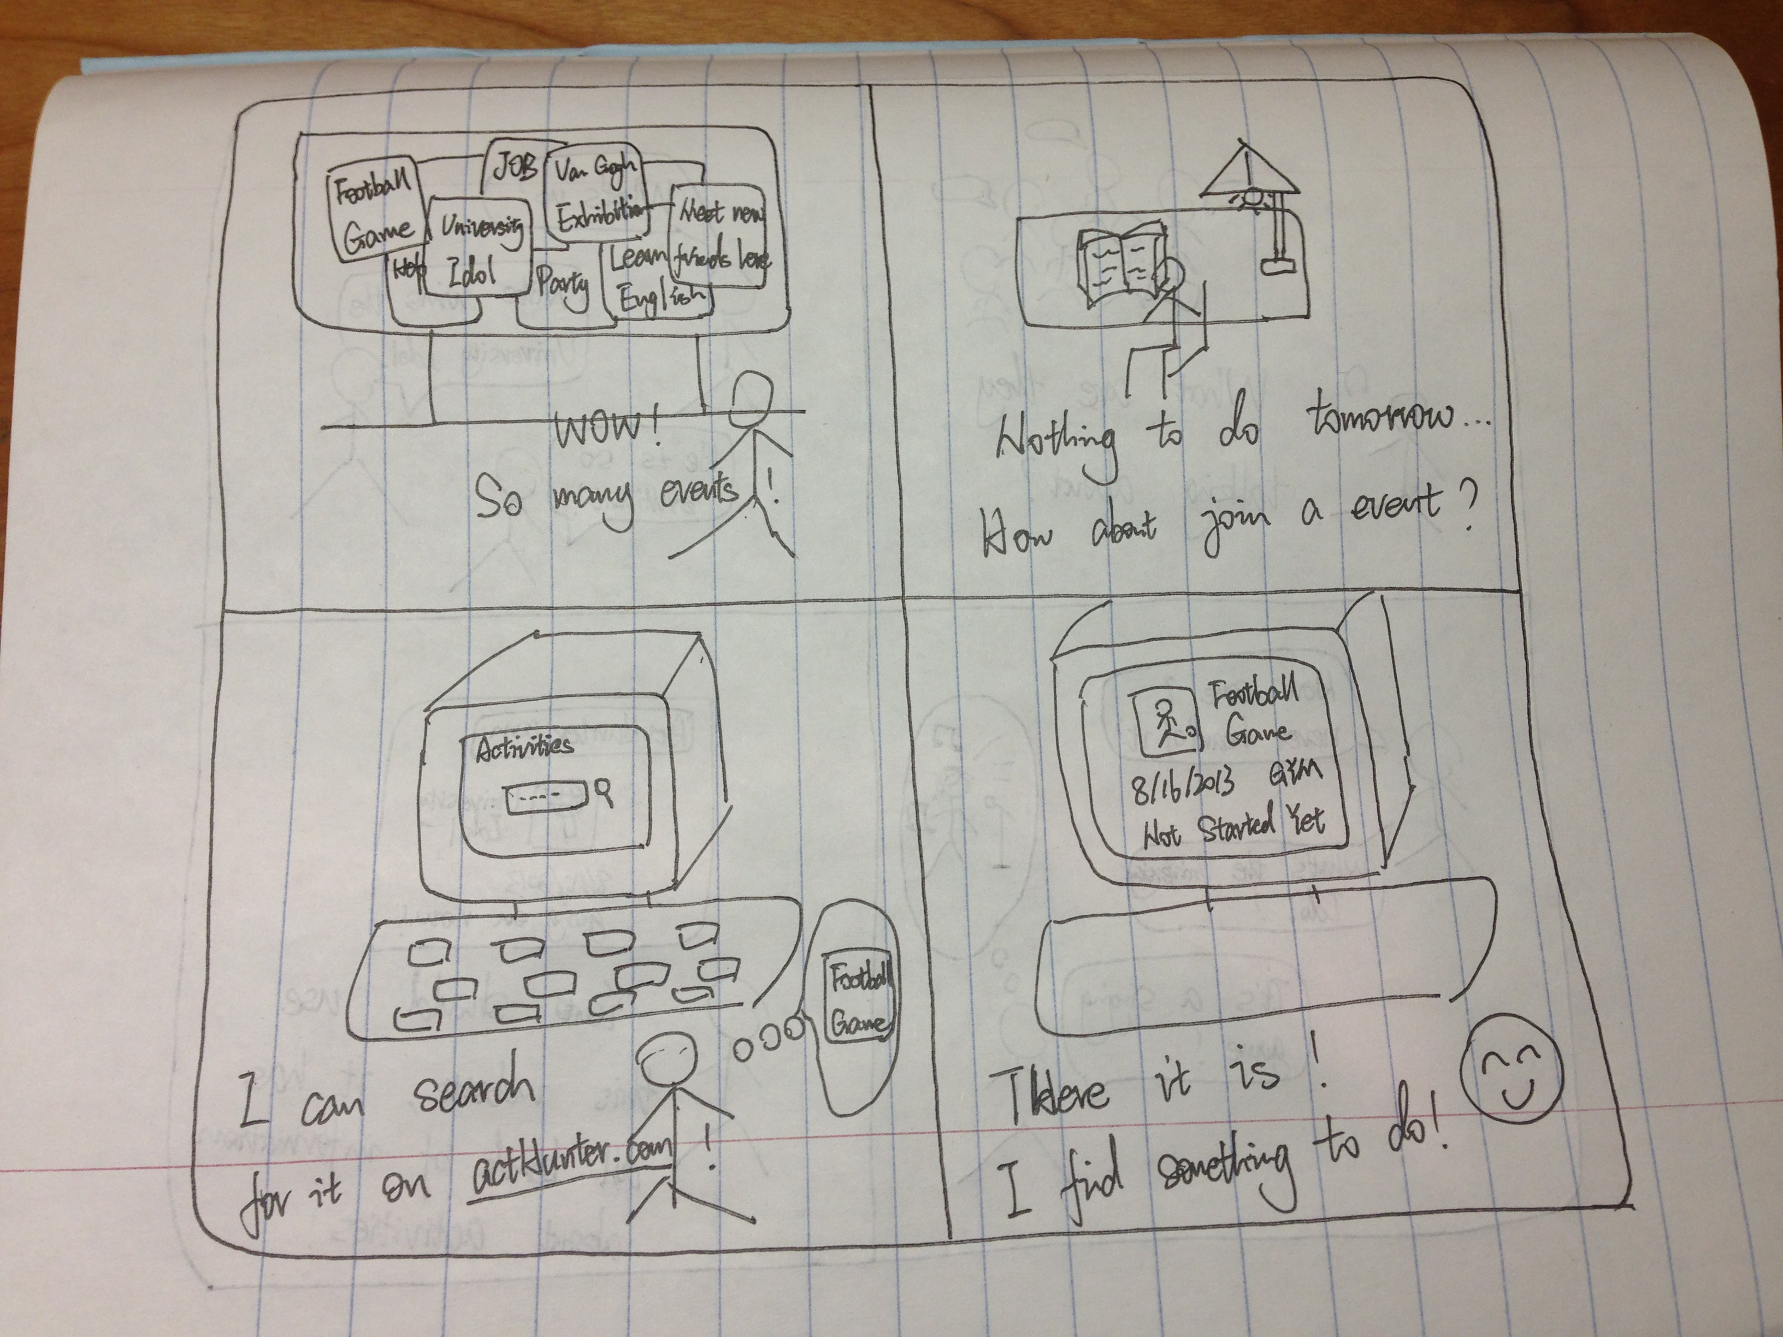 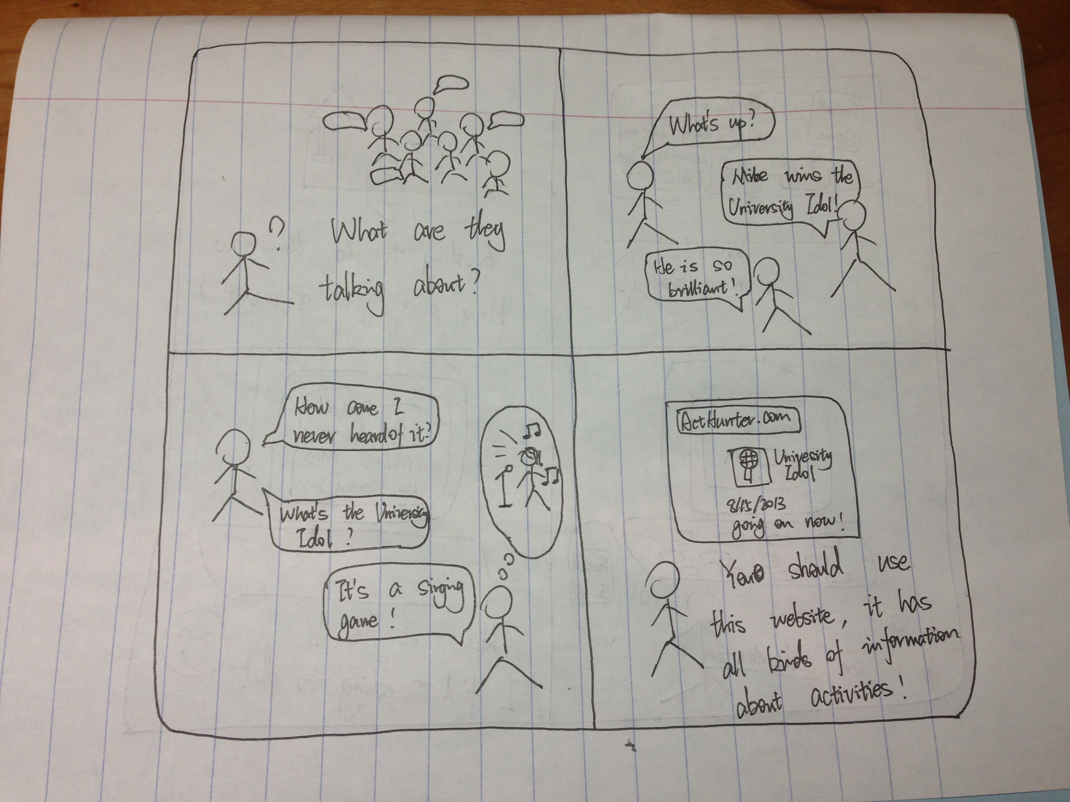

John heard that yesterday there was a perfect performance. He was looking for it for a long time. But he missed it. He is very sad. He ask his friend how where to know these information? His friend just recommends he use our website!

We have argued that display more detail or just to button on Home page?

After heat discussion, we final decide that we only put two button on the homepage which are “For you enjoy”(for students to search event), and “For Organizers”. And if possible, we can add login and sign up button. Why we choose this, because we think that a succinct homepage will stimulate users to use your website.

For participants, they don’t need to sign in if they don’t sign up online.

For organizers, they should register and every time they host event, they should input some information about that .

## Implementation

Give a quick overview of a) how you implemented the product, b) how you organized your code, c) and what functionality it includes. Please also describe functionality that you hard coded such as user login.

Try to limit your response to 200 words or less:

Firstly, Liu Yunong develops skeleton UI. And then Wang Qi and Liu Yunong develop Visually UI, Chao Zichen develops the local storage function based on skeleton. Shi Bowen help Wang Qi and Liu Yunong design visually UI and find usable API and other small function.

At first, we want to use Github to get our code together, but after several try failure, we decided to merge our code artificially.

The hardest model I think is how to store the event information after it was submitted since we can only use HTML, CSS, JQUERY and API. After some tries, Chao Zichen successfully solved the problem user browser store.

In our website, you can post an activity, and it will immediate appear in search list page. We can also share an event to social network.

Although we don’t implement search events function, but we use freebase API to control vocabularies.

## Hypothesis and Metrics

Please define your Value and Growth Hypothesis. For each of the hypothesis, describe what metric you will use to track how successful the product is and at what point (time, value) you know you are on the right track.

Value Hypothesis: I believe Students who want to participate in extracurricular activities, but do not know where to find information will use our website for searching activities and activities organizers will use our website for posting a no

Metric: How many students get useful information from our website.

Threshold: At the beginning, there are less people know our website. So there are few information and target custom on our website. And at that time this website is not attractive for users.

Growth Hypothesis: I believe we will help users to find the events or post events easily customer will continue our website tells other people to use it because our website is easy to use and designed for student!

Metric: number of people new register users

Threshold: It is not easy to cultivate user used to see activities online instead see the posters.